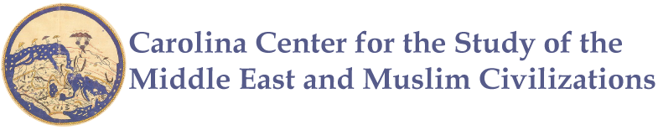
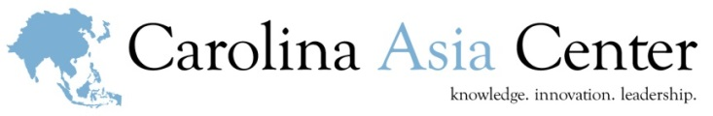

Silk Road, Past and Present: A Workshop for Educators
Lodging Scholarship Application Form

Please complete this form in full, and submit to harver@email.unc.edu.

The Carolina Asia Center and Duke-UNC Consortium for Middle East Studies welcome applications from teachers across North Carolina seeking support to attend the professional development workshop, “Silk Road: Past and Present” on Saturday, April 8. A small number of lodging scholarships (one night double occupancy hotel accommodations in Chapel Hill the evening before the workshop, April 7) are available for teachers traveling more than 200 round-trip miles to the training site (Hill Hall, 145 E Cameron Ave, Chapel Hill, NC 27514). Teachers from schools or districts are welcome and encouraged to apply in pairs. By providing lodging scholarships, we hope to support all North Carolina teachers in attending our trainings.

Guidelines
- Open to all currently practicing K-12 educators in North Carolina traveling more than 200 round-trip miles to the training site at UNC-Chapel Hill.
- The deadline for applications is March 15.
- The applicant(s) must intend on teaching in the consecutive school year.

If you need more information before you submit an application, please contact Emma Harver, Outreach Coordinator, Duke-UNC Consortium for Middle East Studies at 919-962-6732 | harver@email.unc.edu.
APPLICANT INFORMATION
Applicant’s Name (First, Last): |  |  |  |  | Date:
Work Email Address: | Personal Email Address:
Phone Number: ☐ Work ☐ Home ☐ Cell
School District or other Educational Affiliation (please, no acronyms):
Name of Your School: |  |  |  |  |  | Title I? ☐ Yes ☐ No ☐N/A
Principal: |  | Principal’s Email:
School Address: |  |  |  | City: |  |  | Zip Code:
Home Address: |  |  |  | City: |  |  | Zip Code:
Your Role (i.e. Teacher, Administrator, Department Chair, etc.): |  |  | Grade Levels Currently Taught:
Subjects/Courses Currently Taught:

APPLICATION QUESTIONS
- How many years have you been a K-12 teacher? | In North Carolina?
- Please provide a brief description of why you are interested in attending the workshop: (100 word maximum)

- What skills and knowledge do you wish to acquire through this program? How will increased skills and knowledge on this topic impact your teaching and help improve your working relationship with students, improve their learning, and enhance your curriculum? (250 word maximum)

- Would you be able to attend the workshop without a lodging scholarship? ☐ Yes ☐ No
- Have you attended a teacher training event hosted by the Carolina Asia Center or the Duke-UNC Consortium for Middle East Studies? ☐ Yes ☐ No

