Name: ______________________________________________________ Date: _______________

The Cambodian Dancer: Sophany’s Gift of Hope by Daryn Reicherter illustrated by Christy Hale

Every group member must pick an activity to lead. A student can be Comprehension Companion, Vocab Hero, Evidence Detective, or Visual Voice. Students can be more than one role or have multiple people be a role.

Leadership Role: ________________________________________________________________

Pre-Reading Questions
Answer with a partner
- What is an activity that you love doing? How does it make you feel?

- How would you feel about having to leave your country to come to a new country?

Reading Comprehension
The Comprehension Companion will lead the group in this activity.

- Where does Sophany live?

- What does she try to model when she dances?

- What does the dance give her?

- What did Sophany grow up to do in Cambodia?

- Who did Sophany dance for in Cambodia?

- What did the Khmer Rogue destroy in the temples?

- What did Sophany feel the Khmer Rogue turned Cambodia into?

- Where did Sophany go when the Khmer Rogue took over?

- Why was Sophany sad when she saw Cambodian children growing up in America?

- What did Sophany create for the next generation of Cambodian girls?

Vocabulary
The Vocab Hero will lead the group in this activity.
Word in its Original Sentence (underline word) | What I Think it Means by the Way It’s Used | A Dictionary Definition | A Picture to Remember it by
She learned how to look like the stone reliefs on the walls of the temples. | statues | Sculptures usually on a plane surface | 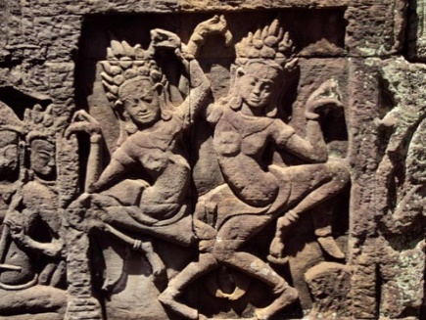
Finding Evidence
The Evidence Detective will lead the group in this activity.
Statement About the Story | Proof from the Text
Sophany loved to dance. | The dance gave her energy.
Sophany taught the specifics of Cambodian dance to girls.
The dance spreads happiness to those who are taught it.
The dancers felt destroyed by the Khmer Rouge.
Sophany felt the other Cambodian children was lost like her in America.
Sophany started to heal her wounds by teaching dance lessons to Cambodian children in America.
Visual Activity
The Visual Voice will lead the group in this activity.
Copyright: ClipArt

