A Song for Cambodia by Michelle Lord illustrated by Shino Arihara

Pre-Reading Questions
Answer with a partner
- How would you feel if a group took over the government and separated you away from your family?

- Has music ever helped make you feel happy when you were feeling sad?

Reading Comprehension
- Where does Arn live?
Northern Cambodia

- Name one thing that happened when the Khmer Rouge came.

- Where did the rest of Arn’s family go when the Khmer Rouge came? Does he ever see them again?

- What did Arn volunteer for at the children’s work camp?

- What happens to Arn’s teacher and some of the other khim players?

- What does Arn spend his time doing in the jungle when he escaped?

- When Arn awoke from his fever, where was he?

- Why was life hard at the refugee camp?

- Who saved Arn in the flood at the refugee camp? Where did Reverend Peter take Arn?

- Where did Arn vow to return at the end of the book?

Vocabulary
Word in its Original Sentence (underline word) | What I Think it Means by the Way It’s Used | A Dictionary Definition | A Picture to Remember it by
Arn endured life in the camp for four long years. | stayed | To hold out against | 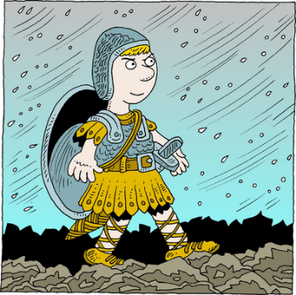

Finding Evidence
Statement About the Story | Proof from the Text
Arn’s childhood home was filled with beautiful sounds. | Sounds of gongs mixed with the songs of birds and the laughter of children.
The work at the children’s labor camp was difficult.
Playing the khim helped make Arn feel happy despite his suffering at the camp.
Life at the refugee camp was still dangerous despite there was no Khmer Rogue.
Arn missed his family and his home when he came to the United States.
Arn wants to return to Cambodia and help his country.
Visual Activity
Copyright: ClipArt
Music-Lover
Afraid of Khmer Rogue

