Name: Date: Period:
Primary Source Documents
Japan

Document A: Yoshitaka Kawamoto who survived the bombing of Hiroshima.
One of my classmates, I think his name is Fujimoto, he muttered something and pointed outside the window, saying, "A B-29 is coming." He pointed outside with his finger. So I began to get up from my chair and asked him, "Where is it?" Looking in the direction that he was pointing towards, I got up on my feet, but I was not yet in an upright position when it happened. All I can remember was a pale lightening flash for two or three seconds. Then, I collapsed. I don’t know much time passed before I came to. It was awful, awful. The smoke was coming in from somewhere above the debris. Sandy dust was flying around… I crawled over the debris, trying to find someone who were still alive. Then, I found one of my classmates lying alive. I held him up in my arms. It is hard to tell, his skull was cracked open, his flesh was dangling out from his head. He had only one eye left, and it was looking right at me… he told me to go away. I, so, was running, hands were trying to grab my ankles, they were asking me to take them along. I was only a child then. And I was horrified at so many hands trying to grab me. I was in pain, too. So all I could do was to get rid of them, it s terrible to say, but I kicked their hands away. I still feel bad about that. I went to Miyuki Bridge to get some water. At the river bank, I saw so many people collapsed there... I was small, so I pushed on the river along the small steps. The water was dead people. I had to push the bodies aside to drink the muddy water. We didn't know anything about radioactivity that time. I stood up in the water and so many bodies were floating away along the stream.
Source: Yoshitaka Kawamoto was thirteen years old. He was in the classroom at Zakoba-cho, 0.8 kilometers away from the hypocenter. He is now working as the director of the Hiroshima Peace Memorial Museum, telling visitors from all over the world what the atomic bomb did to the people of Hiroshima. Taken from Atomic Archive.
Document B: Total casualties of the bombings of Hiroshima and Nagasaki.
The number of total casualties has been estimated at various times since the bombings with wide discrepancies. The Manhattan Engineer District's best available figures are:
TABLE A: Estimates of Casualties
 | Hiroshima |  | Nagasaki
Pre-raid population | 255,000 |  | 195,000
Dead | 66,000 |  | 39,000
Injured | 69,000 |  | 25,000
Total Casualties | 135,000 |  | 64,000
TABLE C: Percent Mortality at Various Distances
Distance from X,  in feet |  | Percent Mortality
0 – 1000 |  | 93.0%
1000 – 2000 |  | 92.0
2000 – 3000 |  | 86.0
3000 – 4000 |  | 69.0
4000 – 5000 |  | 49.0
5000 – 6000 |  | 31.5
6000 – 7000 |  | 12.5
7000 – 8000 |  | 1.3
8000 – 9000 |  | 0.5
9000 - 10,000 |  | 0.0

TABLE D: Cause of Immediate Deaths
Hiroshima
Cause of Death | Percent of Total
Burns | 60%
Falling debris | 30
Other | 10

Nagasaki
Cause of Death | Percent of Total
Burns | 95%
Falling debris | 9
Flying glass | 7
Other | 7

Source: Report compiled by Manhattan Engineer District of the United States Army under the direction of Major General Leslie R. Groves. This report describes the effects of the atomic bombs dropped on Hiroshima and Nagasaki. Taken from Atomic Archive.

Document C: Admiral William E. Leahy, President Truman’s Chief of Staff, on the bombing of Hiroshima and Nagasaki.
"The use of this barbarous weapon at Hiroshima and Nagasaki was of no material assistance in our war against Japan. The Japanese were already defeated and ready to surrender...
"In being the first to use it, we . . . adopted an ethical standard common to the barbarians of the Dark Ages. I was not taught to make war in that fashion, and wars cannot be won by destroying women and children."
— Admiral William E. Leahy
Source: Admiral William E. Leahy writes his thoughts in his memoirs "I Was There." Taken from Morningside Center.

Document D: Photographs of Hiroshima and Nagasaki after the atomic bombs not published, but taken by LIFE Magazine.
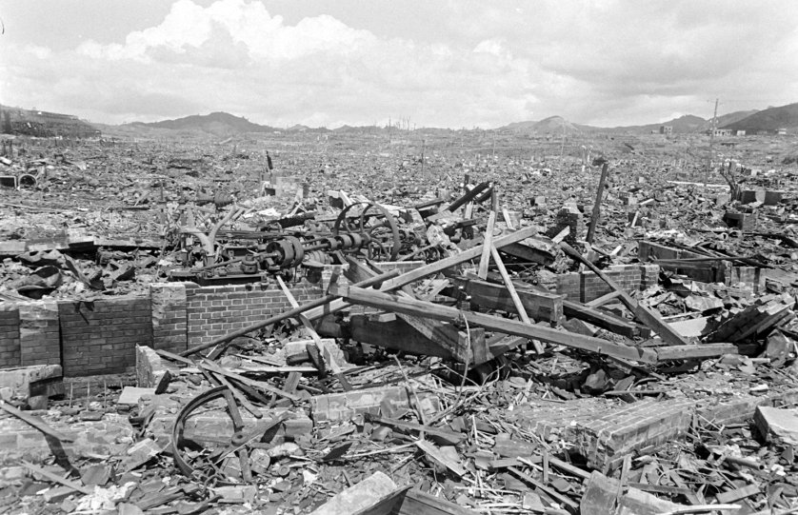
Photo taken from Nagasaki in September 1945.
Source: Photo from LIFE Magazine, not published. Taken from TIME.

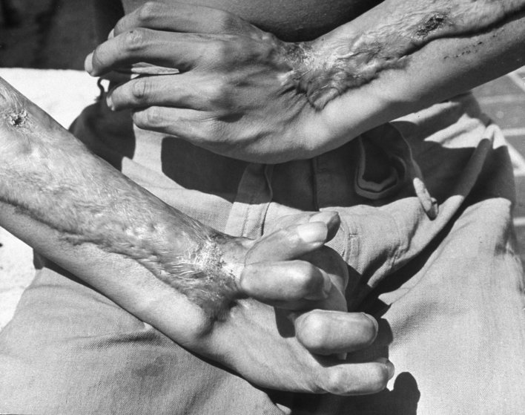
This is a photo of a survivor from the bombing on Hiroshima. He was kept in the hospital two years later with the damage to his hands in 1947.
Source: Photo from LIFE Magazine, not published. Taken from TIME.

