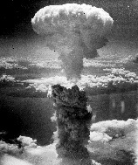
Name: Date: Period:
The Atomic Bomb
History of the Bomb
Japanese Perspective
American Perspective

